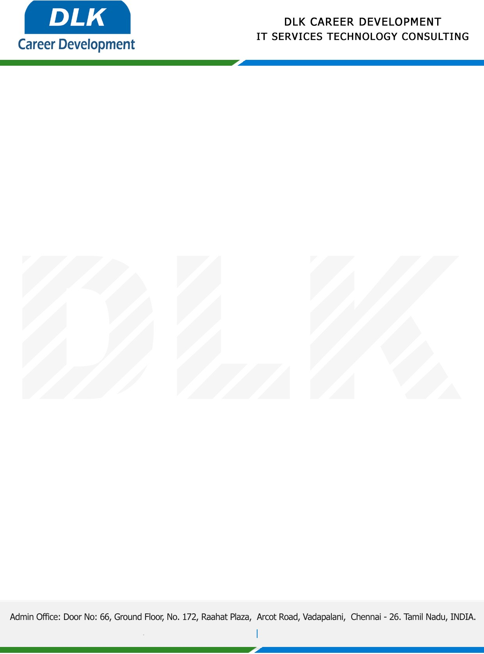

**Date: 19/ April /2023**

**SUB: PROJECT COMPLETION CERTIFICATE**

This is to certify that **MR NANDHAGOPAL P (REG NO:** **9517202152025) MSC- Computer Applications,** final year student **Mepco Schlenk Engineering College,Sivakasi** has Successfully Completed the Project Work under the domain of “**Java”** in our organization during the Period **(27th December 2022 to 19th April 2023).**

**Topic:** Online Digital Rental Management System**.**

We appreciate your interest in **DLK CAREER DEVELOPMENT**

**“Best Wishes for Your Future Endeavors “**

